**FITFLEX(Fitness Tracker)**

**Nan Mudhalvan Project**

Submitted in partial fulfillment of the requirement for the award of

**BACHELOR OF COMPUTER SCIENCE**

Submitted By

**M AFRIN SOFIYA -asunm110222201104**

**M SHERIN AFROSE-asunm110222201217**

**H SUJITHA- asunm110222201220**

**M YUVARANJANI-asunm110222201229**

**P YUVASRI- asunm110222201230**

UG DEPARTMENT OF COMPUTER SCIENCE

**DHARMAMURTHI RAO BAHADUR CALAVALA CUNNAN CHETTY’S**

**HINDU COLLEGE [SHIFT-II]**

“LINGUISTIC (TELUGU) MINORITY STATUS

CONFERRED BY THE GOVT.OF.TAMIL NADU”

Re-Accredited by NAAC –Affillated to the University of Madras

Dharmamurthi Nagar, Pattabiram ,Chennai-600072

**DECLARATION**

I am **M AFRIN SOFIYA** (NM Id:**-asunm110222201104**) Hereby declare that the **Nan Mudhalvan project** work title “**FITFLEX(FITNESS TRACKER)”** submitted to the UG Department of Computer Science, **SMARTINTERZN** in partial fulfillment of the requirement for the award of Bachelor of Computer Science.

I am **M SHERIN AFROSE** (NM Id: **-asunm110222201217**) Hereby declare that the **Nan Mudhalvan project** work title “**FITFLEX(FITNESS TRACKER)”** submitted to the UG Department of Computer Science, **SMARTINTERZN** in partial fulfillment of the requirement for the award of Bachelor of Computer Science.

I am **H SUJITHA** (NM Id: **- asunm110222201220**) Hereby declare that the **Nan Mudhalvan project** work title “**FITFLEX(FITNESS TRACKER)”** submitted to the UG Department of Computer Science, **SMARTINTERZN** in partial fulfillment of the requirement for the award of Bachelor of Computer Science.

I am **M YUVARANJANI** (NM Id: **-asunm110222201229**) Hereby declare that the **Nan Mudhalvan project** work title “**FITFLEX(FITNESS TRACKER)”** submitted to the UG Department of Computer Science, **SMARTINTERZN** in partial fulfillment of the requirement for the award of Bachelor of Computer Science.

I am **P YUVASRI** (NM Id:**-asunm110222201230**) Hereby declare that the **Nan Mudhalvan project** work title “**FITFLEX(FITNESS TRACKER)”** submitted to the UG Department of Computer Science, **SMARTINTERZN** in partial fulfillment of the requirement for the award of Bachelor of Computer Science.

**Table Of Content**

|  |  |
| --- | --- |
| **S.NO** | **Content** |
| **1.** | **INTRODUCTION** |
| **2.** | **FITFLEX** |
| **3.** | **CORE COMPONENTS** |
| **4.** | **BACKEND API** |
| **5.** | **CSS LAYOUT MODULE** |
| **6.** | **CODING** |
| **7.** | **SCREENSHOTS** |
| **8.** | **CONCLUSION** |

**Introduction:**

Welcome to the forefront of fitness exploration with fitflex! Our innovative fitnessapp is meticulously designed to revolutionize the way you engage with exercise routines,catering to the diverse interests of both fitness enthusiasts and seasoned workout professionals. With a focus on an intuitive user interface and a comprehensive feature set,fitflex is set to redefine the entire fitness discovery and exercise experience.Crafted with a commitment to user-friendly aesthetics, fitflex immerses users in an unparalleled fitness journey. Effortlessly navigate through a wide array of exercise

categories with features like dynamic search, bringing you the latest and most effective workouts from the fitness world.

From those embarking on their fitness journey to seasoned workout aficionados, fitflex embraces a diverse audience, fostering a dynamic community united by a shared passion for a healthy lifestyle. Our vision is to reshape how users interact with fitness, presenting a platform that not only provides effective exercise routines but also encourages collaboration and sharing within the vibrant fitness community.Embark on this fitness adventure with us, where innovation seamlessly intertwines with established exercise principles. Every tap within fitflex propels you closer to a realm of diverse workouts and wellness perspectives. Join us and experience the evolution of fitness engagement, where each feature is meticulously crafted to offer a glimpse into the future of a healthier you. Elevate your fitness exploration with fitflex, where every exercise becomes a gateway to a world of wellness waiting to be discovered and embraced. Trust fitflex to be your reliable companion on the journey to staying connected with a fit and active lifestyle.

**Project Goals and Objectives:**

The overarching aim of fitflex is to offer an accessible platform tailored for individuals passionate about fitness, exercise, and holistic well-being.

Our key objectives are as follows:

User-Friendly Experience: Develop an intuitive interface that facilitates easy navigation, enabling users to effortlessly discover, save, and share their preferred workout routines.

Comprehensive Exercise Management: Provide robust features for organizing and managing exercise routines, incorporating advanced search options for a personalized fitness experience.

Technology Stack: Harness contemporary web development technologies, with a focus on React.js, to ensure an efficient and enjoyable us er experience.

**Features of fitflex Recipess:**

Exercises from Fitness API: Access a diverse array of exercises from reputable fitness APIs, covering a broad spectrum of workout categories and catering to various fitness goals.

Visual Exercise Exploration: Engage with workout routines through curated image galleries, allowing users to explore different exercise categories and discover new fitness challenges visually.Intuitive and User-Friendly Design: Navigate the app seamlessly with a clean, modern interface designed for optimal user experience and clear exercise selection.

Advanced Search Feature: Easily find specific exercises or workout plans through a powerful search feature, enhancing the app&#39;s usability for users with varied fitness preferences.

**HTML CODE**

**<!DOCTYPE html>**

**<html lang="en">**

**<head>**

**<meta charset="utf-8" />**

**<link rel="icon" href="%PUBLIC_URL%/women.png" />**

**<meta name="viewport" content="width=device-width, initial-scale=1" />**

**<meta name="theme-color" content="#000000" />**

**<meta**

**name="description"**

**content="Web site created using create-react-app"**

**/>**

**<link rel="apple-touch-icon" href="%PUBLIC_URL%/women.png" />**

**<!--**

**manifest.json provides metadata used when your web app is installed on a**

**user's mobile device or desktop. See https://developers.google.com/web/fundamentals/web-app-manifest/**

**-->**

**<link rel="manifest" href="%PUBLIC_URL%/manifest.json" />**

**<!--**

**Notice the use of %PUBLIC_URL% in the tags above.**

**It will be replaced with the URL of the `public` folder during the build.**

**Only files inside the `public` folder can be referenced from the HTML.**

**Unlike "/favicon.ico" or "favicon.ico", "%PUBLIC_URL%/favicon.ico" will**

**work correctly both with client-side routing and a non-root public URL.**

**Learn how to configure a non-root public URL by running `npm run build`.**

**-->**

**<title>Fit-Flex</title>**

**</head>**

**<body>**

**<noscript>You need to enable JavaScript to run this app.</noscript>**

**<div id="root"></div>**

**<!--**

**This HTML file is a template.**

**If you open it directly in the browser, you will see an empty page.**

**You can add webfonts, meta tags, or analytics to this file.**

**The build step will place the bundled scripts into the <body> tag.**

**To begin the development, run `npm start` or `yarn start`.**

**To create a production bundle, use `npm run build` or `yarn build`.**

**-->**

**</body>**

**</html>**

**EXERSICE.JS**

import React from "@auth0/auth0-react"

import "../styles/exercise.css";

import lunges from "../assets/img/lunges.png"

import yoga from "../assets/img/yoga-pose.png"

import ex from "../assets/img/extended.png"

const Exercise = () => {

return <section>

<div className="container exercise__top">

<div className="exercise__top">

<h2 className="section__title">Benefits of <span className="highlights">Exersice</span></h2>

<p>Exercise is essential for maintaining a healthy body and mind,<br/> and can improve quality of life in numerous ways.</p>

</div>

<div className="exercise__wrapper">

<div className="exercise__item" data-aos-duration="1500" data-aos="zoom-in">

<span className="exercise__icon"><imgsrc={lunges} alt="err" /></span>

<div className="exercise__content">

<h4>Healthy Life</h4>

<p>Living a healthy life involves taking care of both your physical and mental health.</p>

</div>

</div>

<div className="exercise__item" data-aos-duration="1500" data-aos="zoom-in">

<span className="exercise__icon"><imgsrc={yoga} alt="err" /></span>

<div className="exercise__content">

<h4>Increased Flexibility</h4>

<p>Increased flexibility is an important aspect of physical fitness that can offer a range of benefits</p>

</div>

</div>

<div className="exercise__item" data-aos-duration="1500" data-aos="zoom-in">

<span className="exercise__icon"><imgsrc={ex} alt="err" /></span>

<div className="exercise__content">

<h4>Reducing Blood Pressure</h4>

<p>Regular physical activity can help lower blood pressure and improve overall cardiovascular health.</p>

</div>

</div>

</div>

</div>

</section>

}

export default Exercise

**FOOTER.JXS**

import React from "react";

import "../styles/footer.css";

import logo from "../assets/img/Health___Fitness.png";

const Footer = () => {

const year=new Date().getFullYear();

return (

<footer className="footer" data-aos-duration="1100" data-aos="fade-up">

<div className="container">

<div className="footer__wrapper">

<div className="footer__box">

<div className="logo">

<div className="logo__img">

<imgsrc={logo} alt="" />

</div>

<h2>Health & Fitness</h2>

</div>

<p>

"Exercise is a celebration of what your body can do, not a punishment for what you ate."

</p>

</div>

<div className="footer__box">

<h4 className="footer__title">Company</h4>

<ulclassName="footer__links">

<li>

<a href="#">Our Programs</a>

</li>

<li>

<a href="#">Meal Plans</a>

</li>

<li>

<a href="#">Become a member</a>

</li>

</ul>

</div>

<div className="footer__box">

<h4 className="footer__title">Healthy Living</h4>

<ulclassName="footer__links">

<li>

<a href="#">Fitness</a>

</li>

<li>

<a href="#">Nutrition</a>

</li>

<li>

<a href="#">Experts</a>

</li>

</ul>

</div>

<div className="footer__box">

<h4 className="footer__title">Quick Links</h4>

<ulclassName="footer__links">

<li>

<a href="#">About us</a>

</li>

<li>

<a href="#">Contact us</a>

</li>

<li>

<a href="#">Support</a>

</li>

</ul>

</div>

</div>

<p className="copyright">Copyright - {year} developed by Gokul. All rights reserved.</p>

</div>

</footer>

);

};

export default Footer;

**HERO.JSX**

import React from "@auth0/auth0-react"

import heroImg from "../assets/img/model1-removebg-preview.png"

import "../styles/hero.css";

const Hero = () => {

return <section id='#'>

<div className="container">

<div className="hero__wrapper">

<div className="hero__content">

<h2 className='section__title' data-aos-duration="1000" data-aos="fade-up">Exercise is the key to a <span className="highlights">Healthy</span> Lifestyle</h2>

<p data-aos-duration="1100" data-aos="fade-up" data-aos-delay="100">Regular exercise is a crucial component of a healthy lifestyle.<br/>It has numerous benefits for physical and mental health, including reducing the risk of chronic diseases,improving cardiovascular function,<br/> enhancing mood, reducing stress, and promoting better sleep.</p>

<div className="hero__btns" data-aos-duration="1200" data-aos="fade-up" data-aos-delay="200">

<button className='register__btn'>Get Started</button>

<button className='watch_btn'><span><iclassName="ri-play-fill"></i></span>Watch Video</button>

</div>

</div>

<div className='hero__img'>

<div className="hero__img-wrapper">

<div className="box-01">

<div className="box-02">

<div className="box-03">

<div className="box__img">

<imgsrc={heroImg} alt="err" />

</div>

</div>

</div>

</div>

<div className="heart__rate" data-aos-duration="1100" data-aos="fade-right">

<h5>Heart Rate</h5>

<span><iclassName="ri-heart-pulse-fill"></i></span>

<h6>100 BPM</h6>

</div>

<div className="gym__location" data-aos-duration="1100" data-aos="fade-up">

<span><iclassName="ri-map-pin-2-fill"></i></span>

<h5>Find our gym centers near you</h5>

</div>

</div>

</div>

</div>

</div>

</section>

}

export default Hero

**PRINCING.JSX**

import React from "@auth0/auth0-react"

import "../styles/pricing.css"

const Pricing = () => {

return <section id='membership'>

<div className="container">

<div className="pricing__top">

<h2 className="section__title">Premium <span className="highlights">Subscription</span> plan</h2>

<p>Health & Fitness is a popular nutrition and exercise tracking app that offers a premium subscription service.<br/>The premium version includes advanced nutrient tracking, customized goals and advice, and exclusive content.</p>

</div>

<div className="pricing__wrapper">

<div className="pricing__item" data-aos-duration="1500" data-aos="fade-up">

<div className="pricing__card-top">

<h2 className=''>Regular Member</h2>

<h2 className="pricing">$9.99 <span>/month</span></h2>

</div>

<div className="services">

<ul>

<li><span><i class="ri-checkbox-blank-circle-fill"></i></span>Unlimited access to the App</li>

<li><span><i class="ri-checkbox-blank-circle-fill"></i></span>Customer support</li>

<li><span><i class="ri-checkbox-blank-circle-fill"></i></span>Personal trainer</li>

<li><span><i class="ri-checkbox-blank-circle-fill"></i></span>Personal Nutritionist</li>

<li><span><i class="ri-checkbox-blank-circle-fill"></i></span>Demo online classes</li>

</ul>

<button className='register__btn'>Buy Now</button>

</div>

</div>

<div className="pricing__item pricing__item-02" data-aos-duration="1500" data-aos="fade-up">

<div className="pricing__card-top">

<h2 className=''>Gold Member</h2>

<h2 className="pricing">$79.99 <span>/year</span></h2>

</div>

<div className="services">

<ul>

<li><span><i class="ri-checkbox-blank-circle-fill"></i></span>Unlimited access to the App</li>

<li><span><i class="ri-checkbox-blank-circle-fill"></i></span>Customer support</li>

<li><span><i class="ri-checkbox-blank-circle-fill"></i></span>Personal trainer</li>

<li><span><i class="ri-checkbox-blank-circle-fill"></i></span>Personal Nutritionist</li>

<li><span><i class="ri-checkbox-blank-circle-fill"></i></span>Free online classes</li>

<li><span><i class="ri-checkbox-blank-circle-fill"></i></span>Free access to our gym centers</li>

</ul>

<button className='register__btn'>Buy Now</button>

</div>

</div>

<div className="pricing__item" data-aos-duration="1500" data-aos="fade-up">

<div className="pricing__card-top">

<h2 className=''>Standard Member</h2>

<h2 className="pricing">$49.99 <span>/year</span></h2>

</div>

<div className="services">

<ul>

<li><span><i class="ri-checkbox-blank-circle-fill"></i></span>Unlimited access to the App</li>

<li><span><i class="ri-checkbox-blank-circle-fill"></i></span>Customer support</li>

<li><span><i class="ri-checkbox-blank-circle-fill"></i></span>Personal trainer</li>

<li><span><i class="ri-checkbox-blank-circle-fill"></i></span>Personal Nutritionist</li>

<li><span><i class="ri-checkbox-blank-circle-fill"></i></span>Free online classes</li>

</ul>

<button className='register__btn'>Buy Now</button>

</div>

</div>

</div>

</div>

</section>

}

export default Pricing

**START.JSX**

import React from "@auth0/auth0-react";

import tainers from "../assets/img/tainers.png"

import "../styles/start.css";

const Start = () => {

return <section>

<div className="container">

<div className="start__wrapper">

<div className="start__img">

<imgsrc={tainers} alt="err" data-aos-duration="1500" data-aos="fade-left" />

</div>

<div className="start__content" data-aos-duration="1100" data-aos="fade-right">

<h2 className="section__title">Ready to make <span className="highlights">Change?</span></h2>

<p>Remember, it's important to start slowly and gradually increase the intensity and duration of your exercise routine. Consult us as your healthcare provider before starting any new exercise program. Good luck, and enjoy the journey with us towards a healthier you!</p>

<button className="register__btn">Get Started</button>

</div>

</div>

</div>

</section>

}

export default Start

**TESTIMONIALS.JSX**

import React from "react";

import "../styles/testimonials.css";

import { Swiper, SwiperSlide } from "swiper/react";

import "swiper/css";

import "swiper/css/effect-cards";

import { EffectCards } from "swiper";

export default function Testimonials() {

return (

<>

<section id="programs">

<div className="container sliders">

<h2 className="section__title"><span className="highlights">Full-Length </span>Workout Programs</h2>

<Swiper

effect={"cards"}

grabCursor={true}

modules={[EffectCards]}

className="mySwiper"

>

<SwiperSlide>

<div className="slide__item">

<div className="slide__img-01">

<img

src="https://d18zdz9g6n5za7.cloudfront.net/plan/640/640-10651-fb-booty-round-3-4-weeks-of-fun-and-intense-lower-body-training-b234.jpg"

alt="err"

/>

</div>

<h4>42 Min/Day • 4 Weeks</h4>

<p>

FB Booty Round 3: 4 Weeks of Fun and Intense Lower Body

Training Build Strength in Your Glutes, Quads, and Hamstrings

</p>

</div>

</SwiperSlide>

<SwiperSlide>

<div className="slide__item">

<div className="slide__img-02">

<img

src="https://d18zdz9g6n5za7.cloudfront.net/plan/640/640-10355-fb-jumpstart-4-weeks-of-lifting-hiit-cardio-and-stretching-b034.jpg"

alt="err"

/>

</div>

<h4>34 Min/Day • 4 Weeks</h4>

<p>

FB Jumpstart - 4 Weeks of Lifting, HIIT, Cardio,<br /> and

Stretching Progressive Workout Length and Intensity.

</p>

</div>

</SwiperSlide>

<SwiperSlide>

<div className="slide__item">

<div className="slide__img-03">

<img

src="https://d18zdz9g6n5za7.cloudfront.net/plan/640/640-10721-fb-abs-round-3-4-weeks-of-intense-core-training-95d1.jpg"

alt="err"

/>

</div>

<h4>34 Min/Day • 4 Weeks</h4>

<p>

FB Abs Round 3: 4 Weeks of Intense Core Training Intensive

Core Program for Strength and Mobility.

</p>

</div>

</SwiperSlide>

<SwiperSlide>

<div className="slide__item">

<div className="slide__img-03">

<img

src="https://d18zdz9g6n5za7.cloudfront.net/plan/640/640-10194-4-week-fb-strong-round-3-build-muscle-increase-strength-and-feel-great-b642.jpg"

alt="err"

/>

</div>

<h4>40 Min/Day • 4 Weeks</h4>

<p>

4 Week FB Strong: Round 3 - Build Muscle, Increase Strength,

and Feel Great You Choose: 35 Minutes or 50 Minutes a Day

</p>

</div>

</SwiperSlide>

</Swiper>

</div>

</section>

</>

);

}

**TRACK.JSX**

import React from "react";

import { useState, useEffect } from "react";

import { AuthContext } from "../component/AuthContextProvider";

import { useContext } from "react";

import Swal from "sweetalert2";

import "../styles/track.css";

const Track = () => {

const [name, setName] = useState("");

const [activity, setActivity] = useState("");

const [weight, setWeight] = useState("");

const [fat, setFat] = useState("");

const [bmi, setBMI] = useState("");

const [postdate, setPostDate] = useState("");

// const [data, setData] = useState([]);

const [fitData, setFitData] = useState([]);

const [btn,setBtn] = useState(false);

const [loading,setLoading]=useState(false);

const { filter } = useContext(AuthContext);

// const fetchAndRender=()=>{

// fetch(`https://healthandfitness.onrender.com/data/${filter[0].id}`).then((res)=>{

// return res.json();

// }).then((data)=>{setData(data?.userdata)})

// }

// useEffect(()=>{

// fetchAndRender();

// },[filter]);

const getFitnessData = async () => {

let res = await fetch(

`https://healthandfitness.onrender.com/data/${filter[0].id}`

);

let json = await res.json();

let data=json.userdata;

data.sort((a, b) => new Date(b.date) - new Date(a.date));

setFitData(data);

// setData(data?.userdata);

// console.log(data);

};

useEffect(() => {

// getFitnessData();

// console.log(filter,"Rohan");

filter &&filter[0] && filter[0].id && fetch(`https://healthandfitness.onrender.com/data/${filter[0].id}`, {

method: "PATCH",

headers: {

"Content-Type": "application/json",

},

body: JSON.stringify({ userdata: fitData }),

});

}, [fitData, filter]);

const handleSubmit = (e) => {

e.preventDefault();

console.log(filter);

setLoading(true);

// alert("It may take some time to show data on Dashboard, so please be patient.");

let obj = {

id: Math.floor(Math.random() * 100),

workout_name: name,

activity: activity,

weight: weight,

fat: fat,

bmi: bmi,

date: postdate,

};

setFitData([...fitData,obj]);

Swal.fire({

position: "top-mid",

icon: "success",

title: "Your Data has been Added.",

showConfirmButton: false,

timer: 1500,

})

setBtn(false);

};

return (

<div className="container">

<br/>

<h1>

Your <span className="highlights">fitness</span> Dashboard

</h1>

<h2>

Add <span className="highlights">Data</span><span><button id="addnotice-btn" onClick={()=>setBtn(!btn)}>{btn?"x":"+"}</button></span>

</h2>

<div className="model" style={{display:btn?"flex":"none"}}>

<div className="formCont">

<form onSubmit={handleSubmit}>

<label>

Workout name :

</label>

<input

type="text"

name="name"

onChange={(e) =>setName(e.target.value)} required

/>

<br />

<br/>

<label>

Activity :

</label>

<select name="type" onChange={(e) =>setActivity(e.target.value)} required>

<option value="">Select Restaurant Type</option>

<option value="cardiovascular_exercise">

Cardiovascular exercise

</option>

<option value="strength_training">Strength training</option>

<option value="group_fitness_classes">

Group fitness classes

</option>

<option value="High_intensity_interval_training">

High-intensity interval training

</option>

</select>

<br />

<br/>

<label>

Body Weight :

</label>

<input

type="number"

name="Weight"

onChange={(e) =>setWeight(e.target.value)} required

/>

<br />

<br/>

<label>

Body Fat :

</label>

<input

type="number"

name="body_fat"

onChange={(e) =>setFat(e.target.value)} required

/>

<br />

<br/>

<label>

Heart Rate :

</label><br/>

<input

type="number"

name="price_starts_from"

onChange={(e) =>setBMI(e.target.value)} required

/>

<br />

<br/>

<label>Date: </label>

<input

type="date"

data-testid="date"

onChange={(e) =>setPostDate(e.target.value)}

required></input>

<br />

<br/>

<input id="btn" type="submit" onClick={handleSubmit} />

</form>

</div>

</div>

<div className="table-responsive">

<table className="table">

<theadclassName="thead-dark">

<tr>

<th>Workout Name</th>

<th>Activity</th>

<th>Body Weight</th>

<th>Body Fat %</th>

<th>Heart Rate</th>

<th>Date</th>

</tr>

</thead>

<tbody>

{fitData.map((el) => {

return (

<tr key={el.id}>

<td>{el.workout_name}</td>

<td>{el.activity}</td>

<td>{el.weight} Kg</td>

<td>{el.fat}%</td>

<td>{el.bmi} BPM</td>

<td>{el.date}</td>

</tr>

);

})}

</tbody>

</table>

</div>

</div>

);

};

export default Track;

**APP.CSS**

/* google fonts */

@import url("https://fonts.googleapis.com/css2?family=Questrial&display=swap");

:root {

--primary-color: #6f55f2;

--heading-color: #132742;

--bg-gradient: linear-gradient(

90deg,

rgba(103, 101, 240, 1) 27%,

rgba(141, 141, 235, 1) 85%

);

--font-name: "Questrial", sans-serif;

/*

#9785f2

#b5a9f3

#d3cef2

#d7337a

*/

}

*{

margin: 0;

padding: 0;

box-sizing: border-box;

}

body{

font-family: var(--font-name);

}

h1,h2,h3{

font-weight: 700;

}

section{

padding: 50px 0px;

}

a{

text-decoration: none;

color: unset;

}

a:hover{

color: unset;

}

ul{

list-style: none;

}

.container{

width: 1140px;

padding: 0px 15px;

margin: auto;

}

.section__title{

color: var(--heading-color);

font-weight: 700;

}

**APP.JS**

import "./App.css";

import { useEffect,useContext } from "react";

import Aos from "aos"

import Footer from "./UI/Footer";

import Header from "./component/Header";

import AllRoutes from "./component/AllRoutes";

import Login from "./UI/LogIn/Login";

function App() {

useEffect(()=>{

Aos.init();

},[])

return <>

<Header/>

<AllRoutes/>

<Footer/>

{/* <Login/> */}

</>;

}

export default App;

**INDEX.JS**

import React from "react";

import ReactDOM from "react-dom/client";

import App from "./App";

import "remixicon/fonts/remixicon.css";

import "aos/dist/aos.css"

import { BrowserRouter } from 'react-router-dom';

import { Auth0Provider } from "@auth0/auth0-react";

import AuthContextProvider from "./component/AuthContextProvider";

// import { ChakraProvider } from '@chakra-ui/react'

const root = ReactDOM.createRoot(document.getElementById("root"));

root.render(

<Auth0Provider

domain="dev-zum4necui0sk4w4h.us.auth0.com"

clientId="7HtmSMinb1tGjGxiFiC1cSBJ8U53x2kb"

redirectUri={window.location.origin}

>

<AuthContextProvider>

<BrowserRouter>

<App />

</BrowserRouter>

</AuthContextProvider>

</Auth0Provider>

);

**EXERSICE.CSS**

.exercise__top{

margin-bottom: 50px;

text-align: center;

}

.exercise__top h2{

font-size: 2.4rem;

margin-bottom: 1rem;

}

.exercise__top p{

color: var(--heading-color);

font-size: 1rem;

line-height: 28px;

}

.exercise__wrapper{

background: var(--bg-gradient);

border-radius: 0.3rem;

display: flex;

border-radius: 0.5rem;

align-items: center;

justify-content: space-between;

padding: 80px 60px;

}

.exercise__item{

display: flex;

align-items: center;

column-gap: 1.2rem;

width: 33%;

padding: 10px;

}

.exercise__icon{

width: 20%;

height: 20%;

display: flex;

align-items: center;

justify-content: center;

padding: 0.5rem;

border-radius: 5px;

background: #fff;

}

.exercise__iconimg{

width: 100%;

}

.exercise__content{

width: 80%;

}

.exercise__content h4{

font-size: 1.3rem;

color: #fff;

font-weight: 500;

/* margin-bottom: 0.6rem; */

}

.exercise__content p{

font-size: 1rem;

color: #ffffffb8;

}

**FOOTER.CSS**

.footer{

padding: 50px 0px;

background: #eeeaff;

}

.footer__wrapper{

display: flex;

align-items: center;

justify-content: space-between;

column-gap: 2rem;

}

.footer__box{

width: 30%;

/* padding-left: 10px; */

}

.footer__box p{

color: var(--heading-color);

line-height: 28px;

margin-top: 20px;

}

.footer__title{

font-size: 1.2rem;

color: var(--heading-color);

margin-bottom: 20px;

}

.footer__links li{

line-height: 28px;

}

.footer__links li a{

color: var(--heading-color);

cursor: pointer;

}

.footer__links li a:hover{

color: var(--primary-color);

}

.copyright{

margin-top: 30px;

text-align: center;

color: #777;

font-size: 0.9rem;

}

**HEADER.CSS**

.header{

width:100%;

height: 70px;

line-height: 70px;

}

.nav__wrapper{

display: flex;

align-items: center;

justify-content: space-between;

}

.logo{

display: flex;

align-items: center;

column-gap: 0.5rem;

}

.logo__img{

width: 40px;

height: 40px;

padding: 10px;

border-radius: 5px;

line-height: 40px;

display: flex;

align-items: center;

justify-content: center;

}

.logo__imgimg{

width: 500%;

}

.logo h2{

color: var(--heading-color);

font-weight: 700 !important;

}

.menu{

display: flex;

align-items: center;

column-gap: 2.5rem;

}

.nav__item {

color:var(--heading-color);

font-weight: 600 !important;

font-size: 1.1rem;

}

.nav__item:hover{

color: var(--primary-color);

}

.nav__right{

display: flex;

align-items: center;

column-gap: 1.5rem;

}

.register__btn{

border: none;

outline: none;

padding: 10px 20px;

color: #fff;

background-color: var(--primary-color);

border-radius: 5px;

font-family: (--font-name);

font-size: 1rem;

font-weight: 500;

cursor: pointer;

}

.mobile__menu{

color: var(--heading-color);

font-size: 1.3rem;

cursor: pointer;

display: none;

}

.sticky__header{

width: 100%;

position: sticky;

top: 0;

left: 0;

z-index: 99;

background: #fff;

}

**SCREENSHOT**

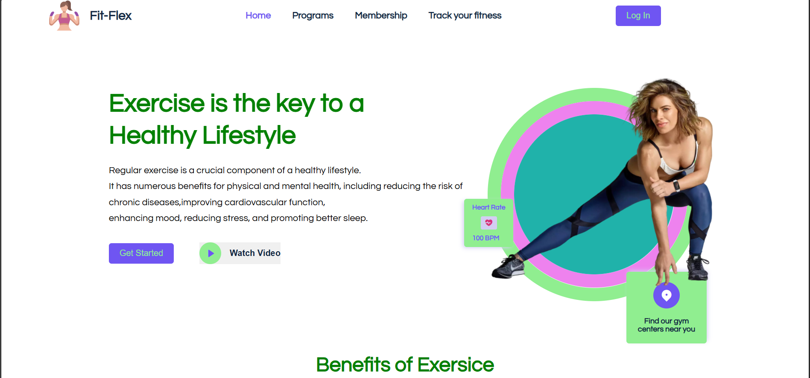

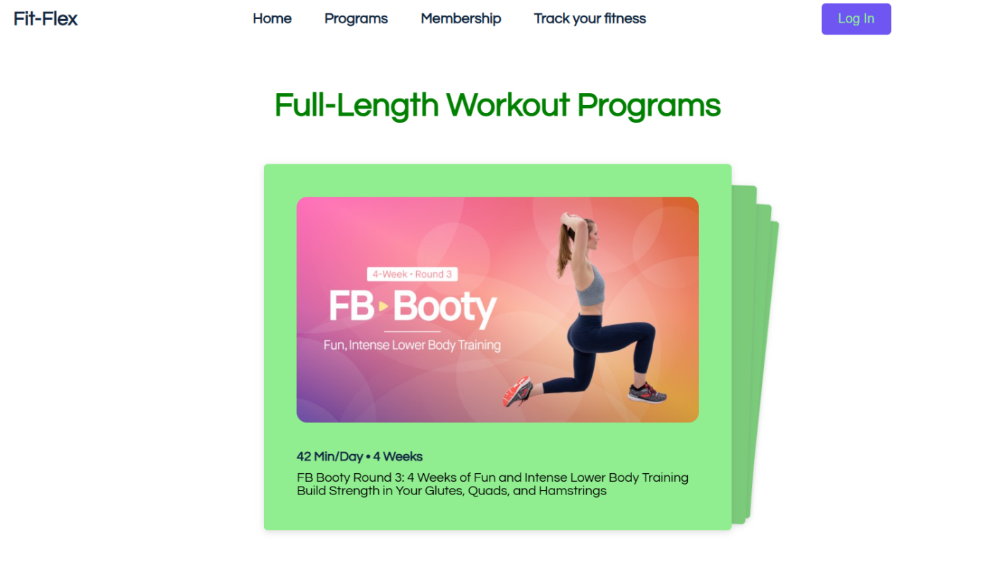

**Conclusion**

In this we Developed the **Fitflex (Tracking) Web using React.js, Html,** **Css and JavaScript** .In this website the user can able to access their fitness and they can also able to attend programs related to fitness .so, it will be useful for the user to access in easier way.